

|  |  |  |
| --- | --- | --- |
| Class: **II/IV B.Tech** | **I Mid-term Examinations** | Date :10/01/2021 |
| Branch: **ECE** | **NETWORK THEORY** | Time :**90 Min** |
| Sub Code: **EC-214** |  | Max. Marks :20 |

**SECTION-A**

**Answer All Questions: (6 x 1 = 6M)**

1. a) What are the passive elements? **(Remember)**

b) State kirchoff’s current law. **(Remember)**

c) Define ‘Tree’ of a graph. **(Remember)**

d) Give the equations for active and reactive power. **(Understand)**

e) Define complex power? **(Remember)**

f) Define the term power factor. **(Remember)**

**SECTION-B (1 x 7 = 7M)**

1. Determine the Resistance between the terminals A and B. (**Evaluate)**

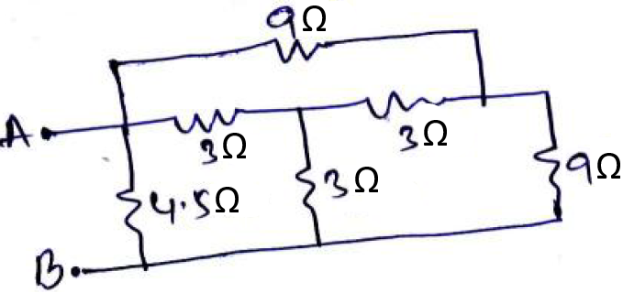

**(OR)**

1. Calculate the current through 4 Resistor in the circuit by nodal method. **(Apply)**

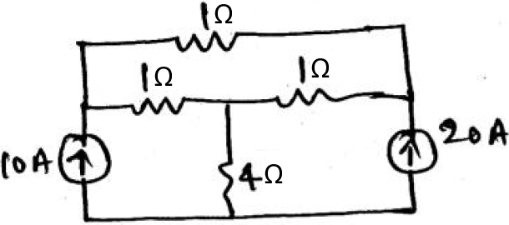

**SECTION-C (1 x 7 = 7M)**

1. A resistance of 10 and a capacitance of 100 F are connected in series across 150V, 50 Hz supply. Calculate (i) Capacitive Reactance (ii) Impedance (iii) Current (iv) Phase angle (v) Power factor (vi) Active power (vii) Reactive power. **(Apply)**

**(OR)**

1. Derive the expression for DC response of R-L series circuit. **(Apply)**